Fundamentals of Web Programming Practical List

NOTE: Following output pattern should be followed through-out the practical. You can choose any color schemes. Also mention your Roll No. on the title bar as shown.

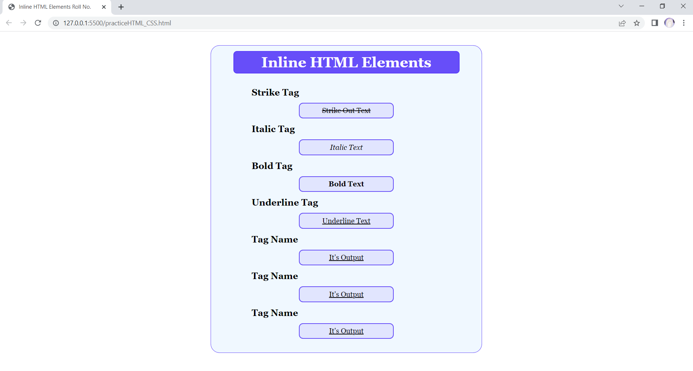

1. Introduction to HTML and its version.
2. Write an HTML and CSS code to show the various Inline HTML elements. Sample output is given below:

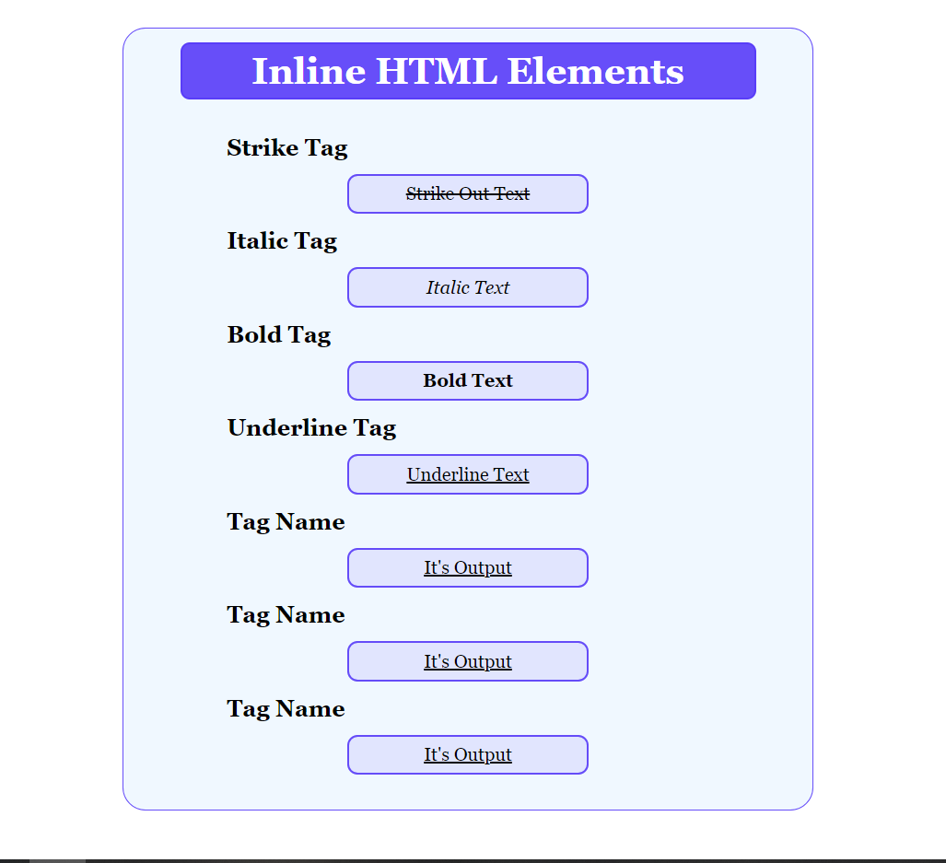

1. Write an HTML and CSS code to show the various Block Level HTML elements.
2. Write an HTML and CSS code to write four paragraphs and align them to left, right, centre and justify respectively using HTML attributes. But set its output layout using CSS only. For this take each <p> in separate <div> tag and show its effects into that div only. Sample output is given below:

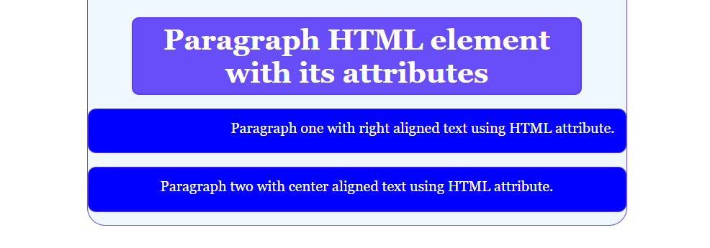

1. Write an HTML and CSS code to move a notification (up, down, left and right) on your webpage using MARQUEE with all of its HTML attributes. Also for this practical take four div and give them all four different directions and also apply its each attribute.
2. Write an HTML and CSS code to design <p> tag as different five buttons of your choice. As a sample one button is shown below:



1. Write an HTML and CSS code to design unordered list as shown below: Fill data of your choice. 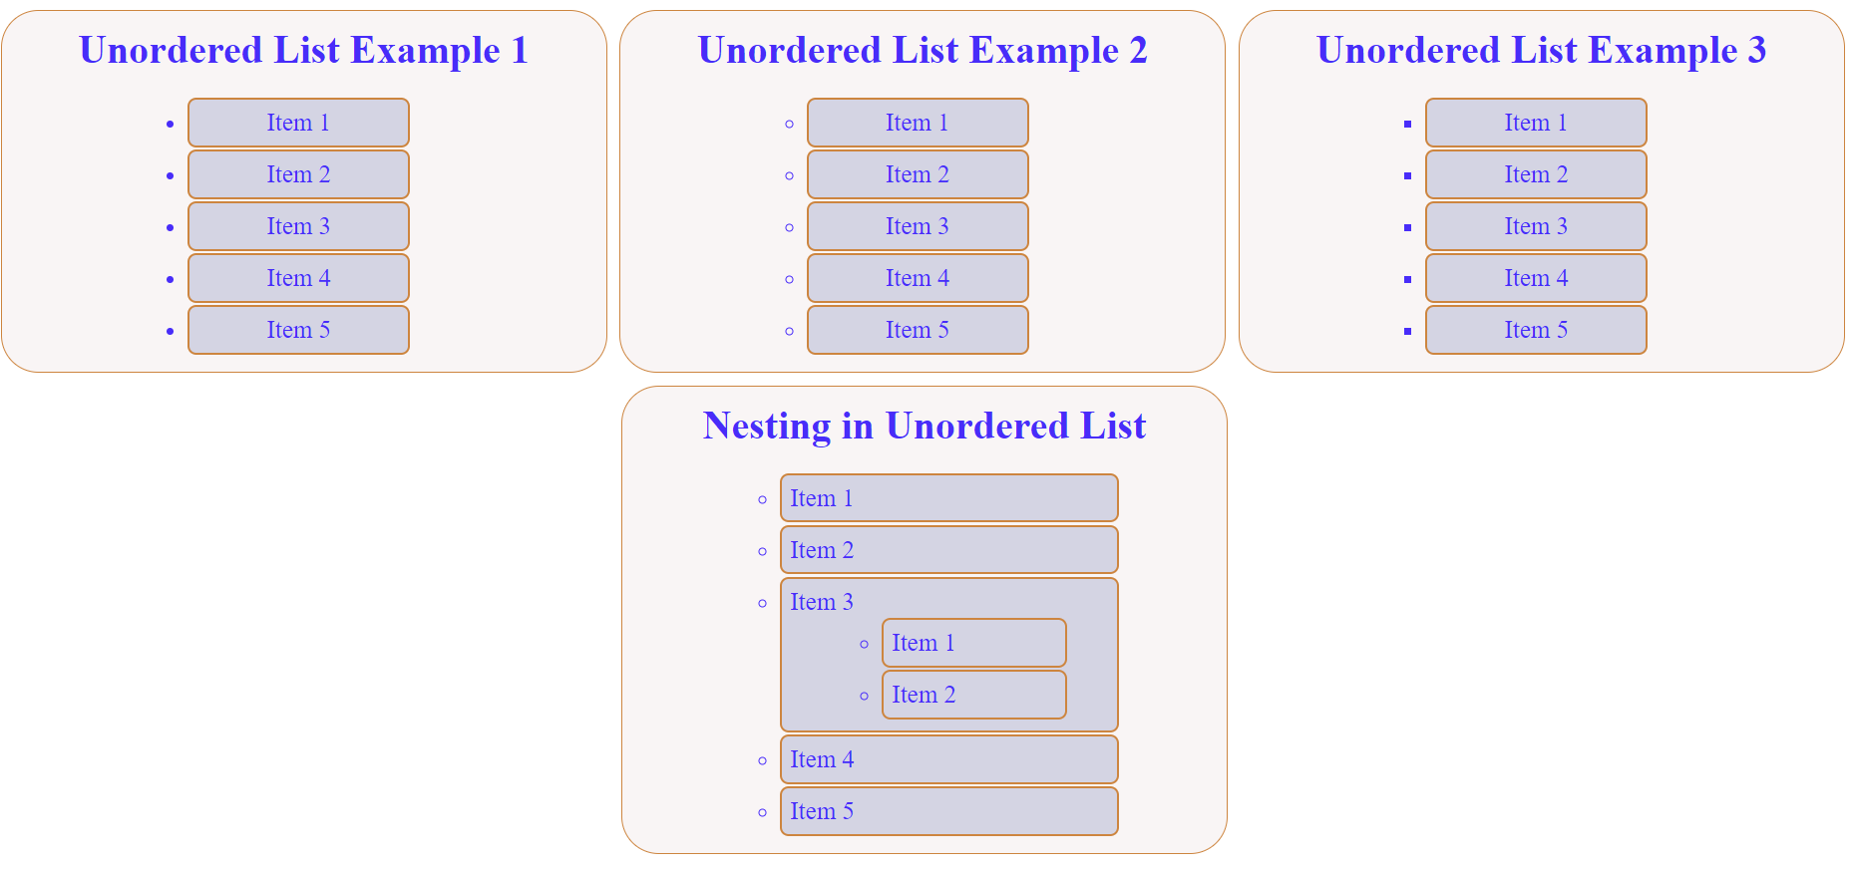
2. Write an HTML and CSS code to design ordered list and follow the same format as given in unordered list with all numbering methods.
3. Write an HTML and CSS code to design the left menu bar of GMAIL using list as shown below.

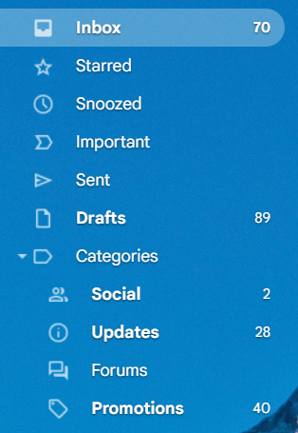

1. Write an HTML and CSS code to design the following navbar using list tag.



1. Write an HTML and CSS code to show the all types of linking using <a> tag with proper format:
   * 1. Between webpages
     2. Between websites
     3. Within single webpage
2. Write an HTML and CSS code to insert an image with all its HTML attributes. Show each align attribute effect in different div.
3. Write an HTML and CSS code to unwrap text and image using extended <br> tag and its clear attributes.
4. Write an HTML and CSS code to map the following image into three parts
   * 1. Laptop (after clicking on laptop all images related to laptop should get open)
     2. Mobile (after clicking on mobile all images related to mobile should get open)
     3. Fruits (after clicking on apple all images related to fruits should get open)



1. Write an HTML and CSS code to design the following calendar using **table tag and its html attributes only**.

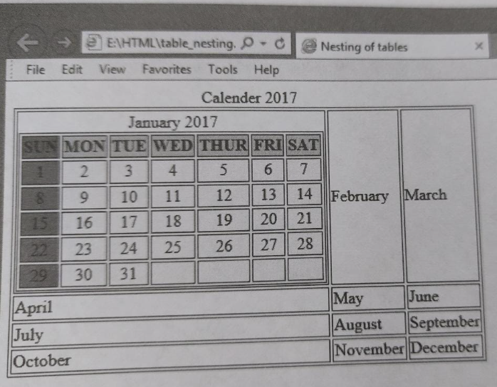

1. Write an HTML and CSS code to design the following table using CSS properties only and also show hover effect on each date.

|  |  |  |  |  |  |  |
| --- | --- | --- | --- | --- | --- | --- |
| May | | | | | | |
| M | T | W | T | F | S | S |
|  | 1 | 2 | 3 | 4 | 5 | 6 |
| 7 | 8 | 9 | 10 | 11 | 12 | 13 |
| 14 | 15 | 16 | 17 | 18 | 19 | 20 |
| 21 | 22 | 23 | 24 | 25 | 26 | 27 |
| 28 | 29 | 30 | 31 |  |  |  |

1. Write an HTML and CSS code to design the following table using CSS properties only and also show hover effect on each row.

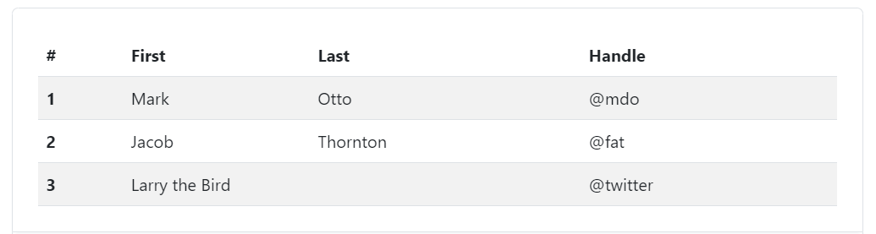

1. Write an HTML and CSS code to design a website on HTML, CSS and JavaScript tutorials with reference to the given website.

